First Aid and Administration
of Medicines Policy

The Study Independent School and Nursery

Introduction

Children and adults in our care need good quality first aid provision. Clear and agreed systems should ensure that all children are given the same care, and understanding, in our school.

The aim of first aid is to save lives and to ensure minor injuries and illnesses do not escalate into major ones.

It is our policy to ensure that appropriate first aid arrangements are in place for our staff, pupils and any visitors to our premises. This includes providing sufficiently trained employees and maintaining an adequate supply of first aid equipment.

This policy should be read in conjunction with the school Health and Safety policy.

Staff training

Staff, including EYFS, receive Epipen training every year.
Staff, including EYFS, received Awareness of asthma training April 2019.
Staff, including EYFS, received Epilepsy awareness training on 20th February 2018.
Staff, including EYFS, may receive other medication administration training when appropriate.

First Aid Training

All members of teaching and learning support staff have first aid training. Training will be updated at least every three years. The school has at least one qualified person on each site (namely the EYFS unit and the KS1 and 2 building) during the school day. All staff running Before and After School care are qualified First Aiders. All staff will be informed of First Aid arrangements and made aware of this policy as part of their induction.

First Aid Equipment

The School Secretary takes care of medication in the school office. There is a fixed locked store for medication, a fridge, fold down bed, privacy folding medical screen and a wash basin is available for incidents occurring on the school site. Toilets are available on the same floor as the school office. This room also has an external phone line for emergency calls. Details of children with severe medical conditions are displayed in the office, staff room and various significant places around school, including the child’s classroom. The first aid kits are located in the school office, on the first floor of the main building and in the staff toilet in the Early Years Building. There is also a small kit suitable for minor cuts during break times behind the door in the boy’s cloakroom. A portable first aid kit is kept in the office, which is provided for out of school visits. We also have a larger first aid kit for Thursday afternoon sports lesson down at the field and for sports fixtures.

The checking and ordering of stock is carried out by the School Secretary, who fills the boxes around school, disposes of any out of date items and ensures that enough stock is maintained to supply the school. There is no first-aid budget; stock is purchased on a need basis.

First Aid Box Contents (guidance only)
A first aid guidance leaflet
40 adhesive hypoallergenic plasters (blue for kitchen staff)
2 triangular bandages
6 safety pins
20 cleaning wipes
2 sterile eye pads
1 pack of 5x20ml pods of eye irrigation fluid
1 large sized unmedicated dressings
4 medium sized unmedicated dressings
6 pairs disposable gloves
Scissors
Eye/Wound irrigation fluid

Accident Procedures

During playtimes and lunchtimes, injuries should be reviewed and treated in the first instance by the teachers on duty. For injuries that require closer attention or more advanced first aid treatment, children should be sent to the office. If the nature of the injury prevents this, the first aider will attend to the injury in the playground, the school secretary will be notified and/or an ambulance called immediately.

Minor incidents and accidents should be dealt with, wounds cleaned e.t.c. in the playground when possible and practical. Persons administering first aid should wear disposable gloves where bodily fluids are involved. An adult witness should be present if tending an intimate part of the body.

During lesson times, if the injury cannot be dealt with in class, the child should be sent to the office, accompanied by another child or adult. If the nature of the injury prevents this, an adult or responsible child should be sent to the office to request first aid assistance and/or an ambulance called.

All injuries are recorded in the relevant accident book, which is kept in the KS2 cloakroom (Yrs
1-6) or the Reception Classroom (Nursery and Reception Classes). This is then copied into the classroom accident book and the member of staff dismissing the pupil will obtain a parent/guardian signature. Children with head bumps/injuries and facial injuries are also given a head bump/facial injury note to take home.

If a child has an accident which requires urgent hospital treatment, the school will be responsible for calling an ambulance in order for the child to receive urgent medical treatment. When an ambulance has been arranged, parents will then be informed and arrangements can be made about where they should meet their child. If parents cannot be contacted, a member of staff, acing ‘in loco parentis’ will accompany the child (taking a completed ‘Hospital Form’ with them detailing vital medical information about the child) and stay with them until the parents arrive.

In the case of non-urgent hospital treatment, parents will be informed immediately and arrangements made for the parents to collect their child to take them to hospital.

EYFS

As with the main school, we can administer medicines to children in EYFS, with prior written consent from the parents. For “as required” medicines, the school secretary will telephone the parent in advance of giving medicine to a child.

If a child falls ill at school the school secretary or class teacher will telephone the parent to arrange collection. The school has a list of infectious diseases from the Health Protection Agency and can advise parents on recommended exclusions from school and/or medical advice needed. We will also send a note home to other parents in the EYFS to notify them (anonymously) of occurrence of illness e.g. chicken pox, scarlet fever.

Should a child in EYFS sustain an accident during the school day the parents will be told verbally by the class teacher when they are collected. A bump/head injury note will also be sent home for any injury to the head. In the event of a more serious injury, but not one that requires further medical attention, the school will also telephone or email the parent before the end of the school day to give information in advance of the child’s home time. Should the first aider decide the child needs further medical attention the child’s parents will be contacted immediately.

At least one member of staff who has a current paediatric first aid certificate will be on site and available at all times when the children are present and will also accompany the children on outings. This paediatric first aid training will be relevant for workers caring for young children. The training will cover the course content as for St John Ambulance or Red Cross paediatric first aid training and will be renewed every three years.

The first aid box is kept in the EYFS staff toilet and is freely accessible at all times. The EYFS Accident book is kept in the Reception Class, behind the classroom door.

Asthma

Class teachers will be informed by the School Secretary about which pupils in their class suffer from asthma. (This information is on the Pupil medical conditions and allergies list which is on permanent display throughout the school including the office and the staff room. A copy is also given to each member of staff at the start of each term).

These pupils should have necessary medication in school and it should be kept accessible in the School Office (white cupboard under the sink). A parent must complete an “Administering Medication Form” and “My Asthma Plan”.

Any such medication should be named. The child should be aware of how to take their own medication, or staff can support them to use their inhaler with a spacer. The inhaler should be with the pupil when they go down to the games field (when it is kept in the First Aid Kit). It should also be taken on school outings and is kept with the nominated first aider. Staff should make themselves aware of the severity of the child’s condition. In the case of a moderate attack, a first aider should be consulted. If no improvement takes place a decision as to whether an ambulance should be called will be made.

Illness
Children who feel unwell should be sent to the school office (for younger children they should be sent with an accompanying note from the teacher explaining the nature of the child’s illness). The decision to send an unwell child home will be made by the Head Teacher. If she is unavailable, the Secretary will make an informed decision about whether or not to send the child home.

Pupils using crutches or with limited mobility
Parents should inform School of the nature of injury and anticipated duration of immobility. Form tutor to arrange for a ‘buddy’ to carry books, open doors etc. Information about the pupil and his/her limitations should be communicated by email to all relevant staff immediately and updates given at the weekly staff meeting.

Pupils with medical conditions
Pupils who have serious allergies, must always have an Epipen in School which is kept in an unlocked box in the main office on a shelf above the storage heater. These are prescription only for that specific child and should not be used by any other pupil. Parents must complete the
‘Administering Medication Form’ for all medications that the School may be required to administer, as well as an “Allergy Action Plan”.

Medication in School
The School Secretary will always administer essential medication to a pupil provided the ‘Administering Medication Form’ has been completed by the parent. This gives written consent by the parent and also ensures that the correct drug is administered at the correct dosage. Every effort must be made to administer the drug at the correct time, although this cannot be guaranteed. Parents are requested where absolutely possible to arrange drug administration outside of the school day.
No child under 16 years of age may be given any medication without their parents written
consent.

Staff Medication
Staff are required to inform the school if they are prescribed any medication that may affect their ability to care for small children. They should inform staff how their medication is to be stored in school.

Non-Prescription medication
Only to be administered by the School Secretary. A teacher may administer this or Paracetamol (or similar) on a School trip or residential trip with prior written consent from the parents. Travel sickness medication may be given if parental written consent has been received by the School in advance.

In the Early Years Department written consent must be obtained for all medications. All medication must be documented and signed for as given.

Prescription-only medication
Prescribed medication may be given to a pupil by the School Secretary provided the ‘Administering Medication Form’ has been completed and signed by the parent. A teacher may also give prescribed medications on a School trip provided written consent and instructions have been received from the parent in advance. Any teacher who has attended training may administer an Epipen if required. Administering Medication Forms are available from the School Office.

Administration of a medicine
The parent must have given written consent to include:
* Name of child
* Name of medicine
* Dose of medicine
* Time medicine to be administered

The medicine should be brought to School in its original container, pharmacy label with child’s name attached and expiry date clearly visible.
The Administrator must:
* Wash their hands
* Confirm the identity of the child
* Administer the medicine
* Document the administration in the Medicines Record Book

Medicines should be stored locked and out of reach of children in the school office. Antibiotics and other medicines requiring cold storage should be kept in the fridge in the store room off the school office.

Vomiting and diarrhoea

There is a bowl in the office for pupils who feel sick. Vomit must be treated as a biohazard and the area must be thoroughly disinfected.

If a child vomits or has diarrhoea in school, they will be sent home immediately. Children with these conditions will not be accepted back into school until at least 24 hours after the last symptom has gone.

Chicken pox and other diseases and rashes

If a child is suspected of having chicken pox e.t.c., a member of staff will check for obvious symptoms. Looking under a child’s clothing anywhere other than on the arms or legs would only be done if the school were concerned about infection to other children. In this case another adult would be present and such action would not be taken without the child’s consent. The child’s parents will be informed.

If a child has any of these infections, they will need to stay off school for a prescribed period of time. The Head Teacher or School Secretary will advise parents of time scales. The school secretary will issue letters to the class/classes.
Head Lice

Unfortunately, head lice are a recurring problem within a school. If a child has head lice, their parent(s) must inform the class teacher immediately (in confidence) and the School Secretary will issue letters to the class.

Pastoral Care

There may be occasions where children state that they are unwell or require First Aid but actually require pastoral care. Incidents requiring pastoral care should be treated as follows:
• If an incident occurs during a teaching session, a member of staff supporting the class / year group should take the child aside, talk to them and decide on any further action required to
ensure the child’s well-being.
• If an incident occurs at break time the teacher on duty should take the child aside, talk to them and decide on any further action required to ensure the child’s well-being. It is the teacher on duty’s responsibility to inform the child’s class teacher.
• If an incident occurs at lunchtime, a member of staff on duty should take the child aside, talk to them and decide on any further action required to ensure the child’s well-being. If they require additional support they will seek the support of the child’s class teacher and in any event will inform them of the incident.

If any member of staff is unsure whether a child is unwell, requires First Aid or requires pastoral care then they are encouraged to send them to the school office.

It is the class teacher’s responsibility to inform parents of significant pastoral care needs.

For any child with a specific medical condition, information is stored in the pupil file and in the case of a child needing an Epipen, a photograph of the child is posted around the school.

The School will contact RIDDOR on 0845 300 99 23 to report injuries diseases and dangerous occurrences where appropriate.

Illness | Recommended Period to be  away from school | Notes
Diarrhoea and/or  Vomiting | 24 hours minimum from last  episode
Chicken Pox | 5 days from onset of rash. | Until spots have healed or crusted over
Impetigo | Until lesions are  crusted or healed | Antibiotic treatment by  mouth may speed healing
Measles and | 5 days from onset of | Preventable by

German Measles (Rubella) | Rash | immunisation
Slapped Cheek or  Fifth Disease | None; Exclusion is ineffective  as  nearly all transmission takes place before the child becomes unwell.
Mumps | 5 days from onset of  swollen glands | Preventable by  immunisation
Scarlet Fever | 5 days after commencing  antibiotics

Information regarding other significant diseases and infections is available in the school office

First Aid and Administration of Medicines Policy Page 8
APPENDIX 1: EMERGENCY CARE PLANS

ALLERGIC REACTIONS MANAGEMENT
Teaching staff will be made aware of any child with life threatening allergies at or before the beginning of term by the School Secretary.

Signs and symptoms of mild allergic reaction
* Rash
* Flushing of skin
* Itching or irritation

Treatment
* Remove allergen if possible e.g. rinse skin, wash out mouth etc
* Administer prescribed antihistamine following procedure above
* Observe victim closely for at least 30 minutes.

ANAPHYLAXIS MANAGEMENT
Rapid signs and symptoms of severe allergic reaction
Anaphylaxis is a rapid developing condition resulting in sudden collapse of the casualty within seconds/minutes:

* Swollen lips, tongue, throat or face
* Nettle type rash
* Difficulty swallowing and/or feeling of lump in the throat
* Abdominal cramps, nausea and vomiting
* Generalised flushing of the skin
* Difficulty breathing, may be very noisy
* Difficulty speaking
* Sudden feeling of weakness caused by fall in blood pressure
* Collapse and unconsciousness

If anaphylaxis is suspected prompt action is required as follows:

* Remove antigen if possible
* Confirm identity of casualty
* Reassure casualty
* Send someone to ask Office staff to call 999 ambulance and casualty’s parents/next of
kin
* Remove Epipen from protective case and remove safety cap at top
* Holding Epipen in a fist like grip push firmly at right angles to outer thigh until auto injector mechanism functions. Hold in place for 10 seconds allowing injector to administer contents of syringe
* Remove Epipen from thigh and massage area
* Note time given
* If casualty has collapsed lay them on their side in the ‘recovery position’
* Monitor breathing (and pulse if trained to do so) Perform CPR if necessary
* Do not leave casualty
* Provide Paramedics with full history of casualty and incident
Epipens are not a substitute for medical attention. If an anaphylactic reaction occurs and an
Epipen is administered the casualty must be taken to hospital.
ASTHMA MANAGEMENT
Teaching staff will be made aware of any child with severe asthma at or before the beginning of term by the School Secretary.

The Study School recognises that asthma is a serious condition which can be life threatening. We ensure that all pupils with asthma can and do fully participate safely in all aspects of school life including out of school activities.

Trigger factors for asthma may include: change in weather conditions, animal fur, viral or chest infection, exercise, pollen, chemicals, air pollutants, emotional situations and excitement.

Persons with asthma need immediate access to their reliever inhaler (usually blue). Younger pupils may need help/encouragement to administer their inhaler. It is the parent’s responsibility to ensure that School is provided with a named, in date reliever inhaler which is always accessible to the pupil. All inhalers are kept in the School Office.

Recognising an asthma attack
* casualty unable to continue an activity or have difficulty with it
* difficulty breathing
* chest may feel tight
* possible wheeze
* difficulty speaking
* increased anxiety
* coughing, sometimes persistent

Action
* Ensure prescribed reliever is taken promptly (either in the classroom or in the school office if it is possible to move the casualty).
* Reassure casualty
* Encourage casualty to adopt a position which is best for them (usually sitting upright)
* Wait 5 minutes if symptoms disappear pupil may resume activity.
* If symptoms have improved but not disappeared, inform parents/next of kin and give another dose of the inhaler.
* Loosen tight clothing
* If there is no improvement in another 5-10 minutes allow casualty to take another dose of their inhaler every minute for five minutes or until symptoms improve.
* An ambulance will be called.
* A member of staff will accompany the casualty to hospital and await the arrival of parent/next of kin.

DIABETES MANAGEMENT
Signs and symptoms of low blood sugar level (hypoglycaemia)
Onset can be quite quick and may be due to a missed/late meal, missing snacks, infection, more exercise, warm weather, too much insulin and stress. Individuals should test their own blood sugar levels if testing equipment available. Symptoms include:

* pale
* glazed eyes
* blurred vision
* confusion/incoherent
* shaking
* headache
* change in normal behaviour-weepy/aggressive/quiet
* agitated/drowsy/anxious
* tingling lips
* sweating
* hunger
* dizzy
* leading to unconsciousness

Action

* Give fast acting glucose (lucozade drink or glucose tablets) - the casualty should have their own emergency supply in School Office. This will raise the blood sugar level quickly
* After 5 - 10 minutes follow this up with further snacks as advised by the parents. Do not leave the casualty unaccompanied at any time
* Allow access to regular snacks and check blood sugar level again and as necessary
* Inform parents as soon as possible

Action to be taken if the pupil becomes unconscious
* Place casualty in recovery position
* Do not attempt to give glucose by mouth as this may cause choking
* Telephone 999
* Inform parents/next of kin as soon as possible
* Accompany casualty to hospital and await arrival of parent

Signs and symptoms of high blood sugar level (hyperglycaemia)
This develops much more slowly over time but can be much more serious if untreated. Caused by too little insulin, eating more carbohydrate, infection, stress and less exercise than normal. Symptoms may include:

Action
* feeling tired and weak
* feeling thirsty
* passing urine more often
* nausea and vomiting
* drowsy
* breath smelling of acetone
* blurred vision
* unconsciousness

* inform School Secretary
* arrange for blood glucose testing if possible
* inform parents/next of kin as soon as possible
* call 999 and accompany casualty, await arrival of parents/next of kin

EPILEPSY MANAGEMENT How to recognise a seizure
There are several types of epilepsy but seizures are usually recognisable by the following
symptoms:

* casualty may appear confused and fall to the ground
* slow noisy breathing
* possible blue colouring around the mouth, returning to normal as breathing returns to normal
* rigid muscle spasms
* twitching of one or more limbs and/or face
* possible incontinence

Action

* try to help casualty to floor if possible but do not put yourself at risk of injury
* move furniture etc. away from casualty in order to prevent further injury
* place a cushion or something soft under the casualty’s head
* clear the area of students
* call School Secretary
* cover casualty with a blanket as soon as possible in order to hide any incontinence
* stay with casualty throughout duration of the seizure
* as the seizure subsides place casualty into recovery position
* inform parents as soon as possible
* administer prescribed medication as appropriate or send for ambulance if this is the casualty’s first seizure or, if a casualty, known to have epilepsy, has a seizure lasting for more than 5 minutes, or if an injury occurs as a result of the seizure. Casualty must be accompanied until parent/next of kin arrives
* casualty to rest for as long as necessary
* reassure other pupils and staff

HEAD INJURY MANAGEMENT

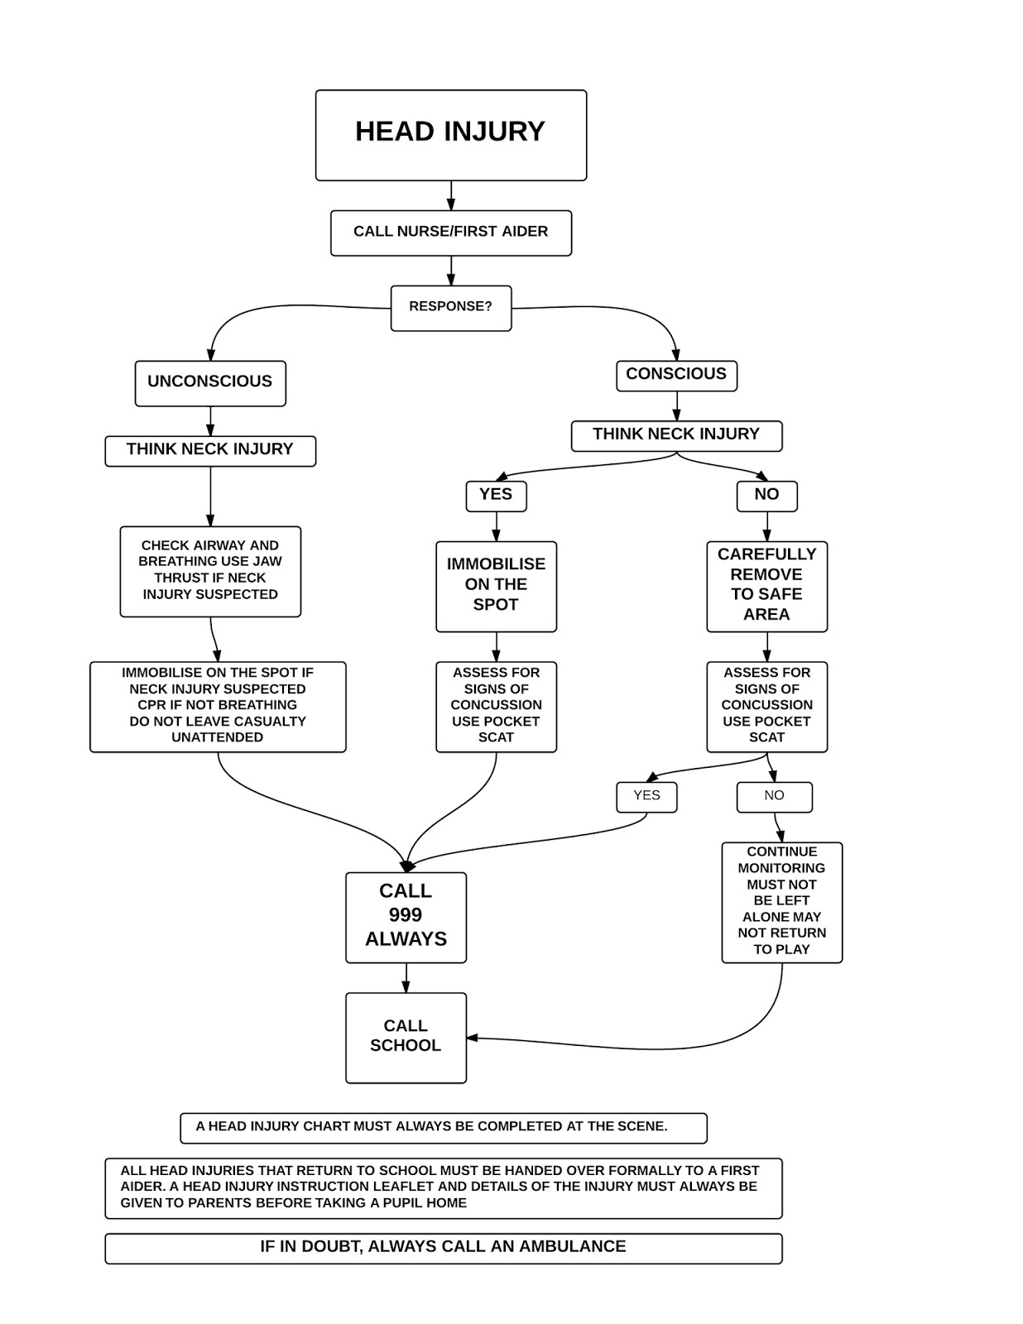

First Aid and Administration of Medicines Policy Page 13

Head Injury Management School
Role

Inform
Parents

Inform School Secretary

Inform Head of School

Make Notes

Consider: Accident Forms/Insurance/ RIDDOR

Administering Medication Form

Child’s Name __________________________________________________________

Date of Birth _______________________

Name/type of Medication _______________________________________________________

Dosage__________________________________________________________

Reason for needing medication _______________________________________________________

Time and dates of Administration ___________________________________________________
-or-
This medicine can be given as and when required: Yes [ ] (parents notified on each occasion)

Are there any side effects of this medication that the school should be aware of? Yes / No

If Yes, please give details: __________________________________________________________

________________________________________________________________________________

________________________________________________________________________________

Medicines will be kept in a secure place by staff in accordance with safety requirements.

I hereby consent to the School Secretary, or a delegated member of staff, administering the above medication according to the details given here and any other relevant medical advice.

Signature of Parent/Carer _________________________________ Date: ________________

Date | Time | Notes | Staff Sign | Parent Sign*

*Parent signature only required if medicine authorised as “as and when required”

Version control
Date of adoption of this policy | September 2018
Date of last review of this policy | September 2020
Date for next review of this policy | September 2021
Policy owner (SLT) | Headteacher
Policy owner (Proprietor) | Proprietor

